**UBUNTU COMMANDS**

**OPERATING SYSTEMS LABS**

**Ubuntu Commands Exploration**

*Submitted By*

AITZAZ TAHIR CH

(19P-0012)

*Submitted to*

MR. MUHAMMAD ABDULLAH

(COMPUTER INSTRUCTOR)

**DEPARTMENT OF COMPUTER SCIENCE**

**FAST NATIONAL UNIVERSITY OF COMPUTER AND EMERGING SCINCES, PESHAWAR**

Session 2019-2023

**Tac Command in Linux**

**Tac** is practically the reverse version of “cat” command (also spelled backwards) which prints each line of a file starting from the bottom line and finishing on the top line to your machine standard output.

**How to use tac?**

Simple, just run the 'tac' command with a filename as input.

**Example:**

tac file-all.txt



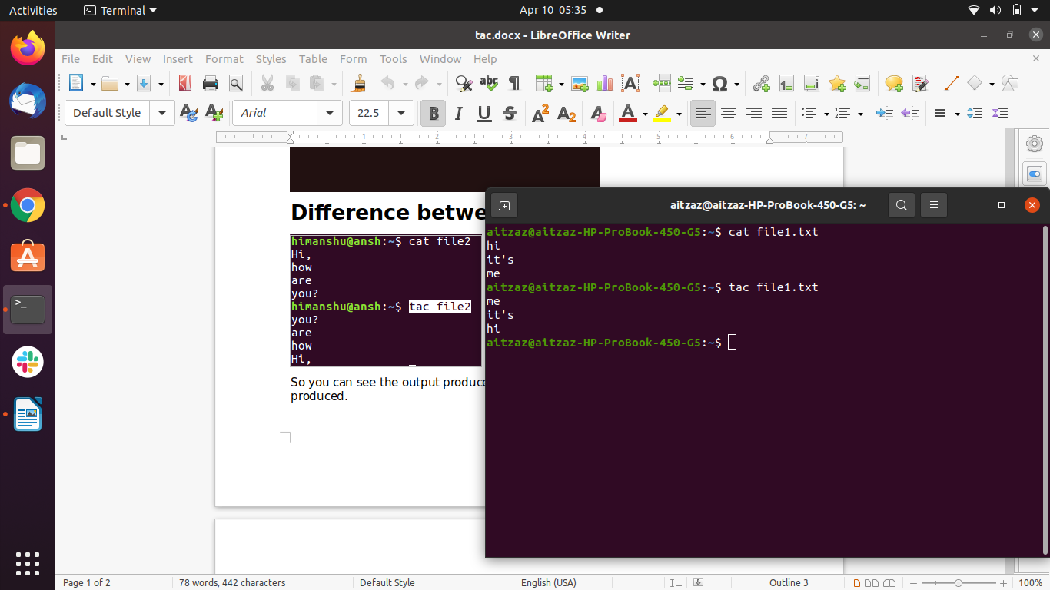**Difference between “tac” and “cat”:**

So you can see the output produced by tac is exactly opposite of what cat produced.

Options:

tac -b or tac –-before :

This option attach the separator before instead of after.

Example:

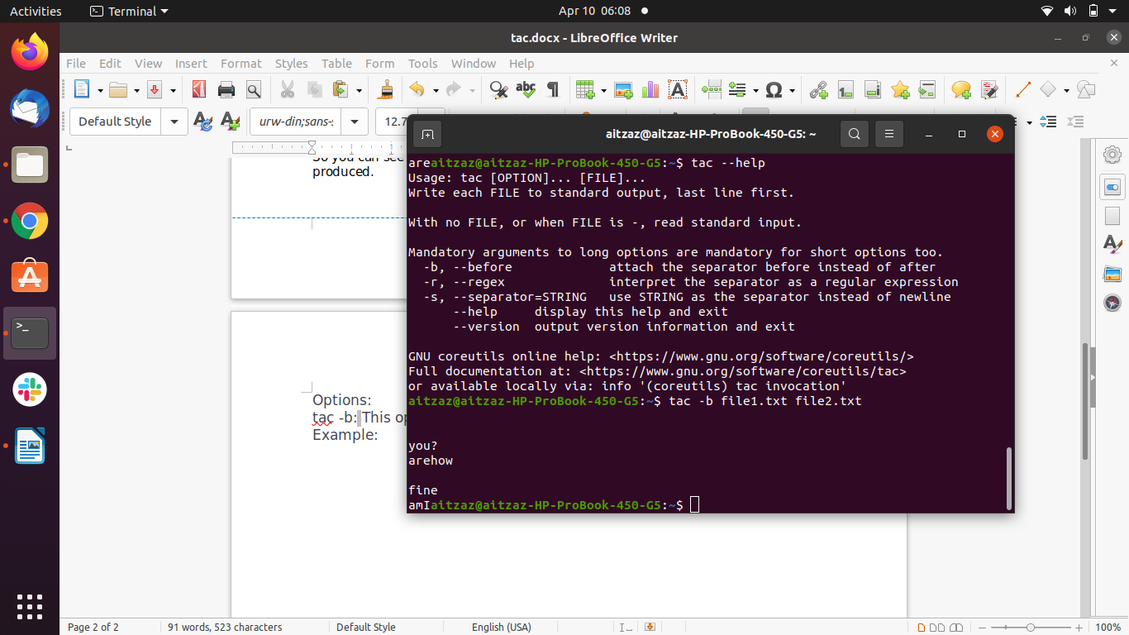tac -r: or tac –-regex :

This option will interpret the separator as a regular expression.

Example:

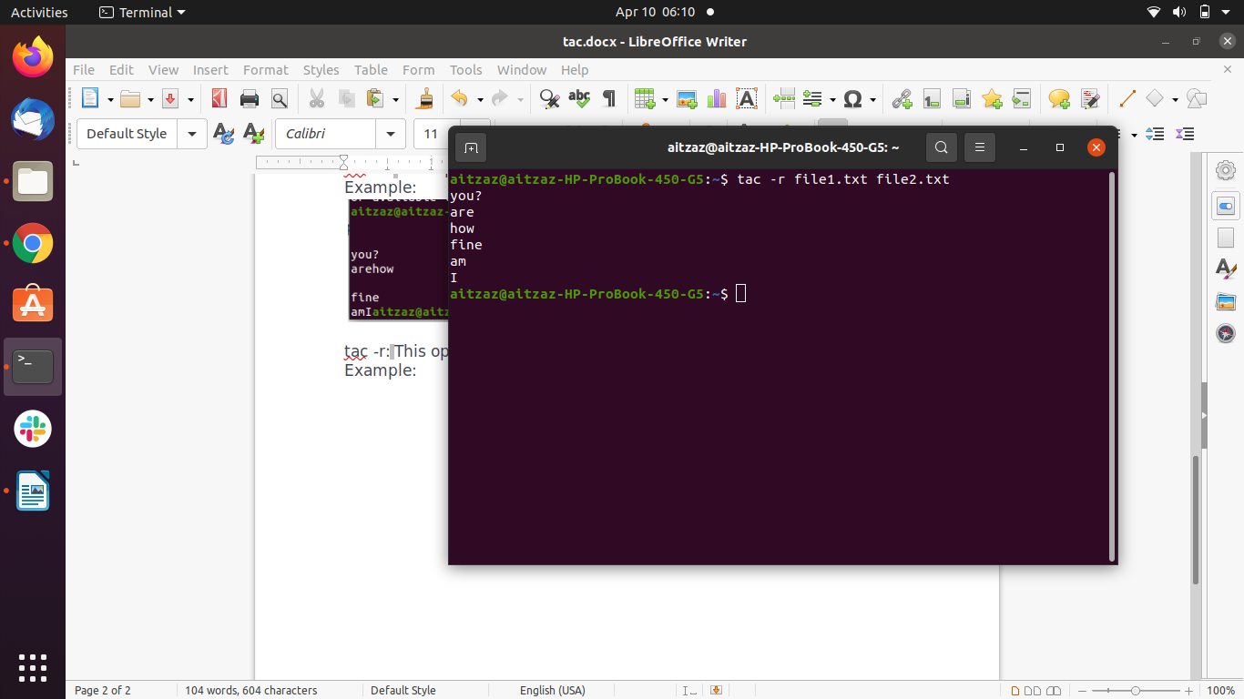tac -s or tac –-separator :

This option use STRING as the separator instead of newline.

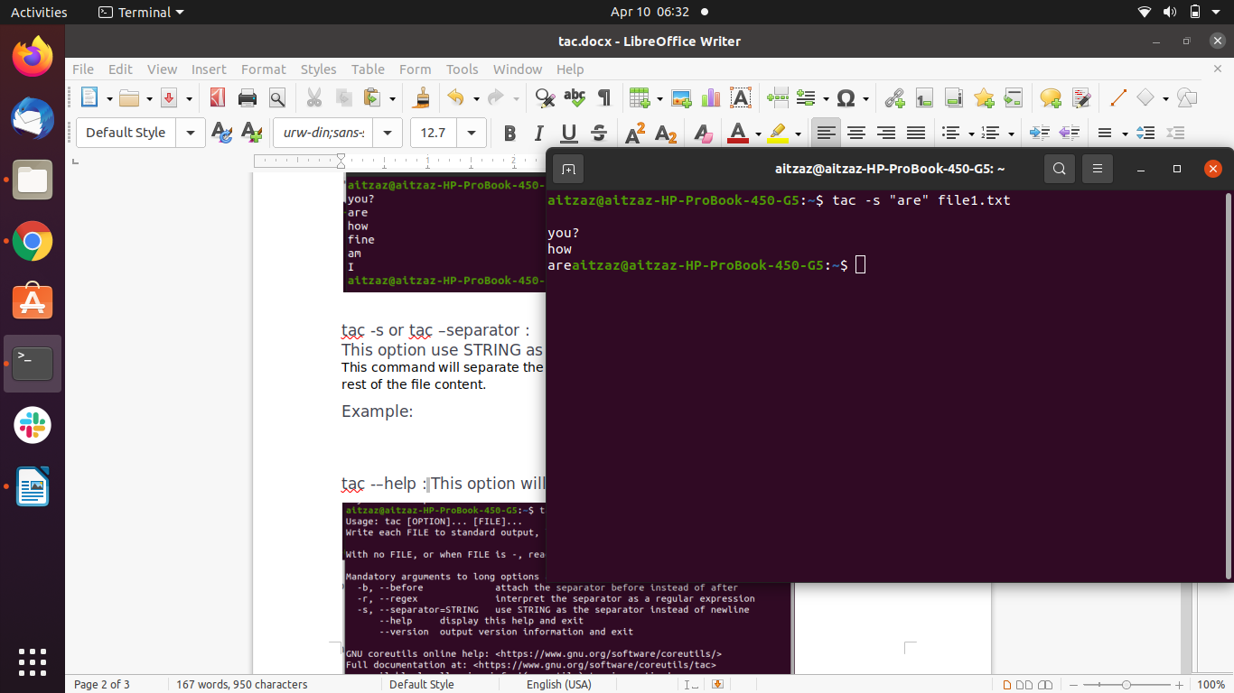This command will separate the content from the mentioned string or keyword from the rest of the file content.

tac -–help :

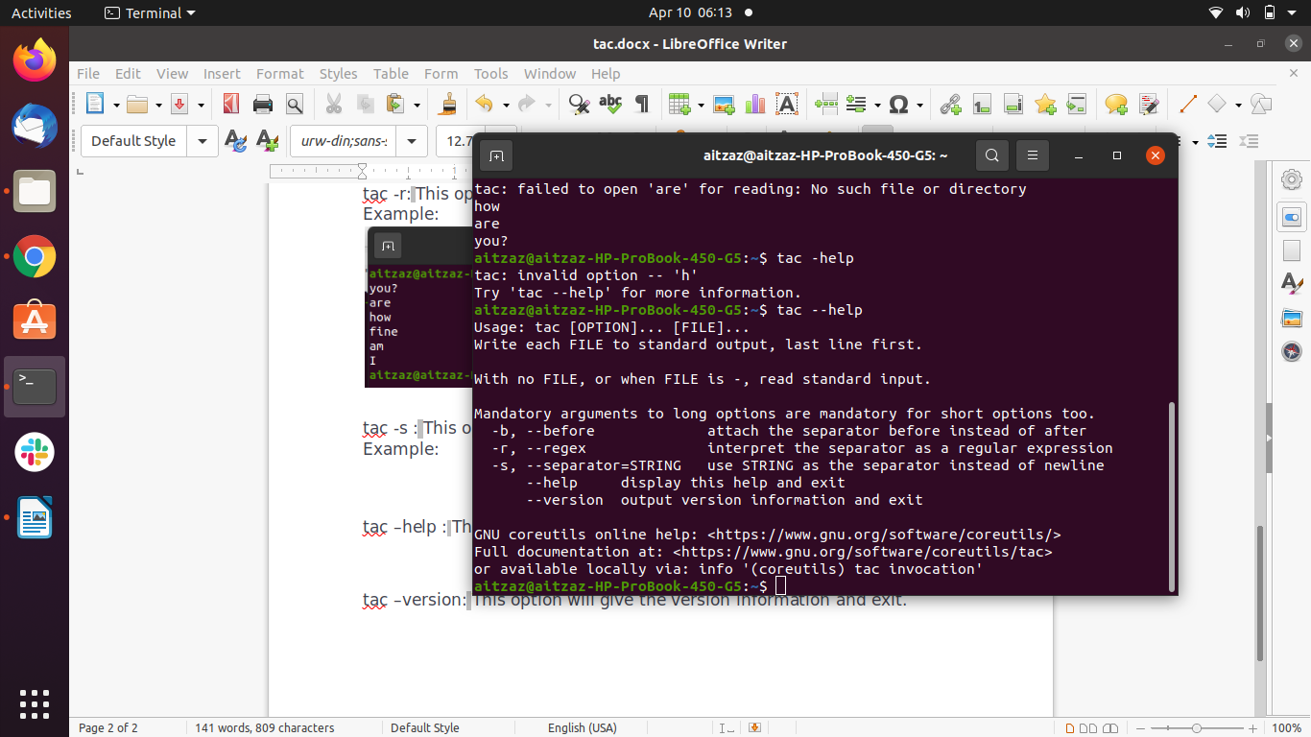This option will display the help text.

tac –version:

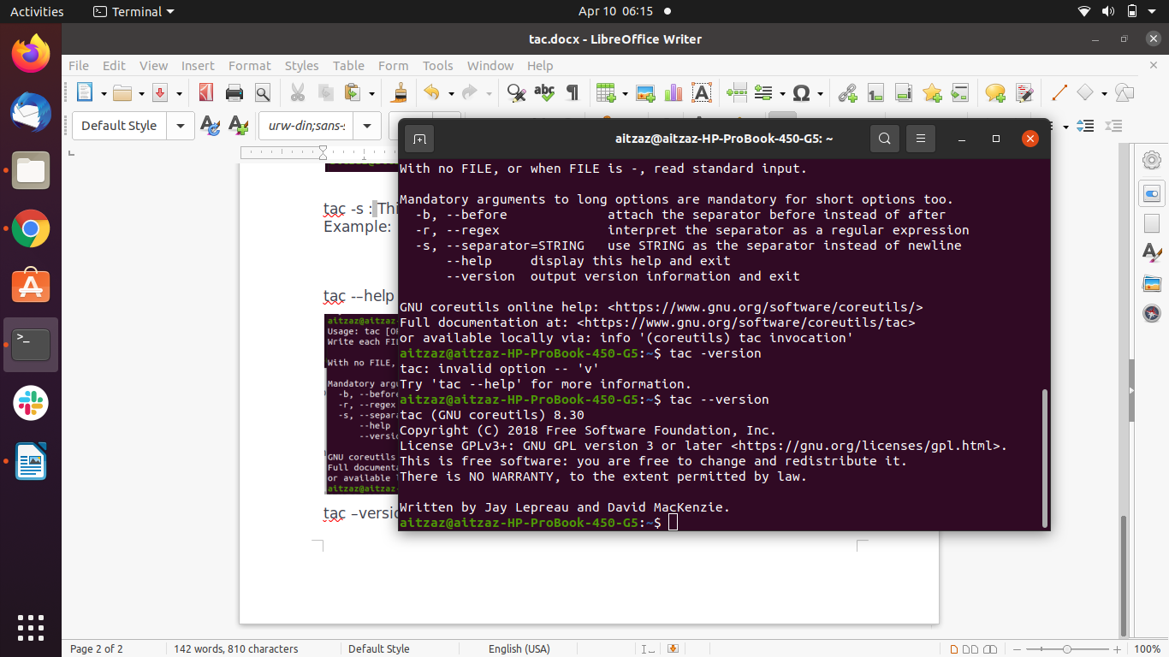This option will give the version information.